PHASE 4: SUBMISSION DOCUMENT
FAKE NEWS DETECTION USING NLP



INTRODUCTION
- Fake news is dangerous as it can deceive people easily and create a state of confusion among a community.
- The fake news has been rapidly increasing in numbers. It is not a new problem but recently it has been on a great rise.
- Techniques of NLP and Machine learning can be used to create models which can help to detect fake news. In this paper we have presented six LSTM models using the techniques of NLP and ML. The datasets in comma-separated values format, pertaining to political domain were used in the project.
PROJECT OVERVIEW
Detecting fake news using machine learning techniques would mean having an automatic detection system that looks at a piece of text (tweets, news articles, a WhatsApp message) and determine how likely it looks like a piece of false news.
The system will be a machine learning model trained on a large enough dataset containing examples of real and false news from various sources and styles. Machine learning models performing binary classification can be trained on this training set. However, since machine learning models only look at numerical features, we must perform natural language processing on this text corpus (collection of text samples).
DESIGN THINKING
DATA SET
Here I will explain the data set.
In this python project, we have used the CSV dateset. True data set contains 21418 rows and 4 columns and False data set contains 23503 rows and 4 columns.
DATA COLLECTION
This data set has four columns:
1. Title: This represents the title of the news.
2. Text: This column has the news itself.
3. Subject: This column shows subject of the news.
4. Date: This column shows when news has created.

TRUE NEWS:
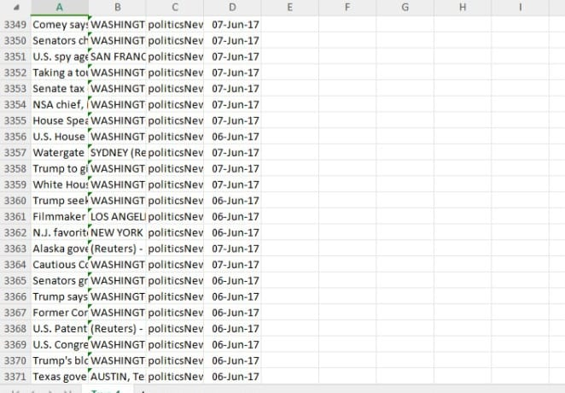
FAKE NEWS:
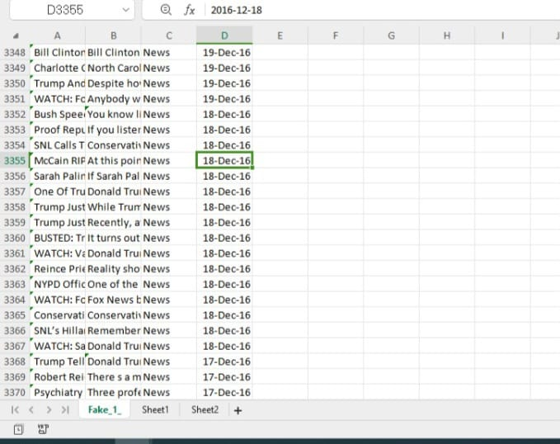

LIBRARIES:
The following libraries are some of the libraries used in the design of the predicting system.
Numpy - to perform a wide variety of mathematical operations.
Pandas - data analysis and associated manipulation of tabular data in DataFrames.
Sk-learn - To implement machine learning model and statistical modelling.
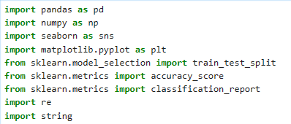

Read dataset from CSV File:
data_fake = pd.read_csv(‘fake.csv’)
data_true = pd.read_csv(‘True.csv’)

OUTPUT:
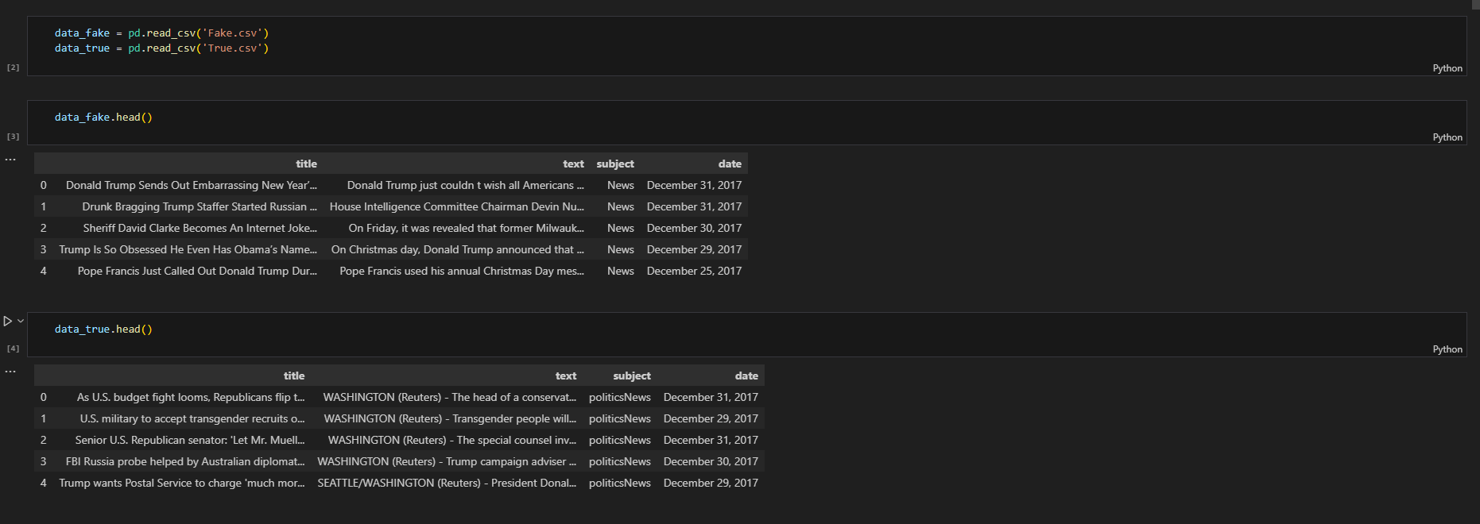

DATA PRE-PROCESSING
In data processing, we will focus on the text column on this data which actually contains the news part. We will modify this text column to extract more information to make the model more predictable. To extract information from the text column, we will use a library, which we know by the name of ‘nltk’.
Here we will use functionalities of the ‘nltk‘ library named Removing Stopwords, Tokenization, and Lemmatization. So we will see these functionalities one by one with these three examples. Hope you will have a better understanding of extracting information from the text column after this.

1. Removing Stopwords:
These are the words that are used in any language used to connect words or used to declare the tense of sentences. This means that if we use these words in any sentence they do not add much meaning to the context of the sentence so even after removing the stopwords we can understand the context.

2. Tokenization:
Tokenization is the process of breaking text into smaller pieces which we know as tokens.
Each word, special character, or number in a sentence can be depicted as a token in NLP.
Tokenization is the process of breaking down a piece of code into smaller units called tokens.

CONCLUSION:
The passive-aggressive classifier performed the best here and gave an accuracy of 93.12%.
Many people consume news from social media instead of traditional news media. However, social media has also been used to spread fake news, which has negative impacts on individual people and society. In this paper, an innovative model for fake news detection using machine learning algorithms has been presented. This model takes news events as an input and based on twitter reviews and classification algorithms it predicts the percentage of news being fake or real.

